24CSI024 - Data Structures and Algorithms
Unit 1: Introduction to Data Structures and Algorithms Arrays and Array-Based Techniques

Lab Workbook - 09.07.2026

CATEGORY: EASY

Question 1: Squaring a Sorted Array (Two-Pointer)
Anjali is processing seismic intensity readings stored in a non-decreasing sorted array. The readings can contain negative values as well as positive values. To calculate the kinetic energy of these waves, she needs to square each value and return a new array containing the squares in non-decreasing order.
The operation must be completed in O(N) time using the two-pointer technique.

Approach Given
- Initialize a left pointer at index 0 and a right pointer at index N - 1.
- Compare the absolute values of arr[left] and arr[right].
- Square the larger absolute value and place it from the end of the output array.
- Move the corresponding pointer and repeat until the output array is filled.

Input Format
- The first line contains an integer N representing the number of readings.
- The second line contains N space-separated integers representing the sorted wave intensities.

Output Format
- Print a single line of N space-separated integers representing the sorted squared values.

Code Constraints
- 1 <= N <= 10000
- -10000 <= arr[i] <= 10000
- The input array is sorted in non-decreasing order.

Sample Test Cases

Input 1:
5
-4 -1 0 3 10

Output 1:
0 1 9 16 100

Input 2:
4
-7 -3 2 3

Output 2:
4 9 9 49

Solution

Aim
To write a C program that squares each element of a sorted array and prints the squared values in sorted order using the two-pointer technique in O(N) time.

Pseudocode

Read N and the sorted array arr.
Set left = 0, right = N - 1, and pos = N - 1.
While left <= right, compare abs(arr[left]) and abs(arr[right]). Place the larger square at result[pos].

Move the pointer that supplied the larger value and decrement pos. Print the result array.

C Program
#include <stdio.h> #include <stdlib.h>

int main() { int n;
scanf("%d", &n);

int arr[10000], result[10000]; for (int i = 0; i < n; i++) {
scanf("%d", &arr[i]);
}

int left = 0, right = n - 1, pos = n - 1; while (left <= right) {
int leftAbs = abs(arr[left]); int rightAbs = abs(arr[right]);

if (leftAbs > rightAbs) {
result[pos] = arr[left] * arr[left]; left++;
} else {
result[pos] = arr[right] * arr[right]; right--;
}
pos--;
}

for (int i = 0; i < n; i++) { printf("%d", result[i]); if (i < n - 1) {
printf(" ");
}
}
printf("\n"); return 0;
}

Screenshot of the Output
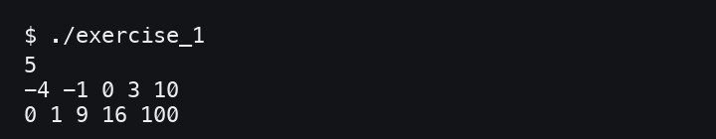

Result
Thus, the sorted squared array was produced successfully using the two-pointer technique.

CATEGORY: EASY

Question 2: Cumulative Resource Consumption (Prefix Sum)
Kabir is monitoring a data transmission line. He receives a log of packets transmitted each hour over N hours. To generate an hourly usage report, he wants to compute the cumulative running sum of packets transmitted from the start up to each hour.

Approach Given
- Let the prefix sum array be P.
- P[0] = arr[0].
- For every i >= 1, P[i] = P[i - 1] + arr[i].

Input Format
- The first line contains an integer N representing the number of hours.
- The second line contains N space-separated integers representing the packets transmitted each hour.

Output Format
- Print a single line of N space-separated integers representing the cumulative running sum.

Code Constraints
- 1 <= N <= 10000
- 0 <= arr[i] <= 100000

Sample Test Cases

Input 1:
5
10 20 5 15 30

Output 1:
10 30 35 50 80

Input 2:
3
0 0 5

Output 2:
0 0 5

Solution

Aim
To write a C program that computes the prefix sum array for a given list of hourly packet transmissions.

Pseudocode

Read N and the array arr. Set runningSum = 0.
For each element arr[i], add it to runningSum. Store runningSum as the prefix sum at index i. Print all prefix sum values.

C Program
#include <stdio.h>

int main() { int n;
scanf("%d", &n);

long long runningSum = 0;
for (int i = 0; i < n; i++) { long long value; scanf("%lld", &value); runningSum += value; printf("%lld", runningSum); if (i < n - 1) {

printf(" ");
}
}
printf("\n"); return 0;
}

Screenshot of the Output
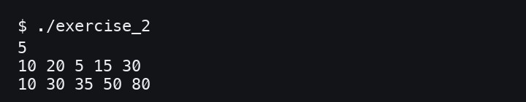

Result
Thus, the cumulative running sum was calculated successfully using prefix sums.

CATEGORY: MEDIUM

Question 3: Grouping Active Sectors (Fixed-Size Sliding Window)
Sam is working on a flash storage defragmentation algorithm. The sectors are represented by a binary array where 1 means active data and 0 means empty. He wants to group all active sectors together in one contiguous block.
The task is to find the minimum number of swaps required to bring all 1s together using a fixed-size sliding window.

Approach Given
- Count the total number of 1s in the array as C.
- If C is 0 or 1, no swaps are needed.
- Find the window of size C that contains the maximum number of 1s.
- The answer is C minus the maximum number of 1s in any such window.

Input Format
- The first line contains an integer N representing the number of sectors.
- The second line contains N space-separated binary values.

Output Format
- Print the minimum swaps in the format: Min Swaps: X.

Code Constraints
- 1 <= N <= 10000
- arr[i] is either 0 or 1.

Sample Test Cases

Input 1:
6
1 0 1 0 1 0

Output 1:
Min Swaps: 1

Input 2:
5
1 1 1 0 0

Output 2:
Min Swaps: 0

Solution

Aim
To write a C program that finds the minimum number of swaps needed to group all 1s together in a binary array using a fixed-size sliding window.

Pseudocode

Read N and the binary array.
Count the total number of 1s as onesCount. If onesCount is 0 or 1, print 0 swaps.
Count the number of 1s in the first window of size onesCount.
Slide the window through the array and track the maximum number of 1s in any such window.
Print onesCount - maximumOnes as the minimum swaps.

C Program
#include <stdio.h>

int main() { int n;
scanf("%d", &n);

int arr[10000], onesCount = 0;

for (int i = 0; i < n; i++) { scanf("%d", &arr[i]);
if (arr[i] == 1) { onesCount++;
}
}

if (onesCount <= 1) { printf("Min Swaps: 0\n"); return 0;
}

int currentOnes = 0;
for (int i = 0; i < onesCount; i++) { currentOnes += arr[i];
}

int maxOnes = currentOnes;
for (int i = onesCount; i < n; i++) { currentOnes += arr[i] - arr[i - onesCount]; if (currentOnes > maxOnes) {
maxOnes = currentOnes;
}
}

printf("Min Swaps: %d\n", onesCount - maxOnes); return 0;
}

Screenshot of the Output
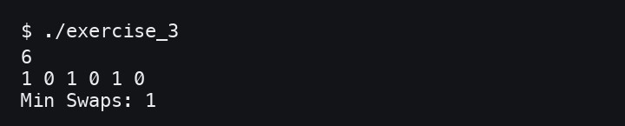

Result
Thus, the minimum swaps required to group all active sectors was found successfully.

CATEGORY: MEDIUM

Question 4: Maximum Task Window Within Budget (Variable-Size Sliding Window)
Riya is scheduling processes on an embedded processor. Each process has an energy cost, and the processor has a strict power limit P for any contiguous execution sequence.
She needs to find the maximum number of consecutive tasks that can be executed without their total energy exceeding P.

Approach Given
- Maintain a start pointer and a running sum.
- Move the end pointer from left to right and add each task cost.
- If the running sum exceeds P, move start forward until the sum becomes valid.
- Track the maximum valid window length.

Input Format
- The first line contains two integers N and P.
- The second line contains N positive integers representing the energy costs.

Output Format
- Print the maximum consecutive tasks in the format: Max Length: X.

Code Constraints
- 1 <= N <= 10000
- 1 <= arr[i] <= 10000
- 1 <= P <= 100000000

Sample Test Cases

Input 1:
5 8
3 1 2 4 5

Output 1:
Max Length: 3

Input 2:
4 5
6 7 8 9

Output 2:
Max Length: 0

Solution

Aim
To write a C program that finds the maximum length of a contiguous task sequence whose total energy cost does not exceed the given budget.

Pseudocode

Read N, P, and the energy cost array.
Initialize start = 0, currentSum = 0, and maxLength = 0. For each end index, add arr[end] to currentSum.
While currentSum > P, subtract arr[start] and increment start. Update maxLength with the current valid window size.
Print maxLength.

C Program
#include <stdio.h>

int main() { int n;
long long p;
scanf("%d %lld", &n, &p);

int arr[10000];
for (int i = 0; i < n; i++) { scanf("%d", &arr[i]);
}

int start = 0, maxLength = 0; long long currentSum = 0;

for (int end = 0; end < n; end++) { currentSum += arr[end];

while (currentSum > p && start <= end) { currentSum -= arr[start];
start++;
}

int length = end - start + 1; if (length > maxLength) {
maxLength = length;
}
}

printf("Max Length: %d\n", maxLength); return 0;
}

Screenshot of the Output
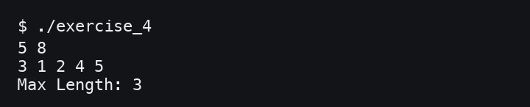

Result
Thus, the maximum number of consecutive tasks within the energy budget was found successfully.

CATEGORY: HARD

Question 5: Sliding Window Maximum Peak (Monotonic Window Queue)
Rohan is building a real-time graphics rendering system. The system receives frame rendering times, and he must calculate the peak rendering time in every sliding window of K consecutive frames.
To achieve O(N) time, he uses a monotonic deque that stores indices of useful maximum candidates.

Approach Given
- Maintain deque indices so their corresponding values are in decreasing order.
- Remove indices from the back when their values are less than or equal to the current value.
- Remove the front index if it falls outside the current window.
- When the window is formed, the front index stores the maximum value for that window.

Input Format
- The first line contains two integers N and K.
- The second line contains N integers representing frame rendering times.

Output Format
- Print one line of space-separated integers representing the maximum for each sliding window of size K.

Code Constraints
- 1 <= K <= N <= 10000
- -100000 <= arr[i] <= 100000

Sample Test Cases

Input 1:
8 3
1 3 -1 -3 5 3 6 7

Output 1:
3 3 5 5 6 7

Input 2:
4 2
4 3 2 1

Output 2:
4 3 2

Solution

Aim
To write a C program that prints the maximum value in every sliding window of size K using a monotonic queue.

Pseudocode

Read N, K, and the array arr.
Create an array-based deque to store indices.
For each index i, remove smaller or equal values from the back of the deque. Insert i at the back of the deque.
Remove indices from the front if they fall outside the current window. Once the first window is formed, print arr[deque front] as the window maximum.

C Program
#include <stdio.h>

int main() {
int n, k;
scanf("%d %d", &n, &k);

int arr[10000], deque[10000]; for (int i = 0; i < n; i++) {

scanf("%d", &arr[i]);
}

int front = 0, rear = -1;
for (int i = 0; i < n; i++) {
while (front <= rear && arr[deque[rear]] <= arr[i]) { rear--;
}

deque[++rear] = i;

if (deque[front] <= i - k) { front++;
}

if (i >= k - 1) {
printf("%d", arr[deque[front]]); if (i < n - 1) {
printf(" ");
}
}
}
printf("\n"); return 0;
}

Screenshot of the Output
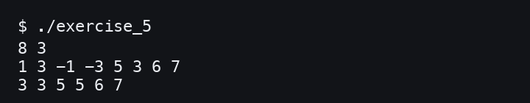

Result
Thus, the maximum value for every sliding window was printed successfully using a monotonic queue.

Viva Questions and Answers

We often describe a List or a Queue as an Abstract Data Type (ADT), while an Array is a concrete data structure. In C, how do we enforce separation between an ADT's interface and its underlying array implementation?
We keep the interface in a header file and hide the implementation details in a separate source file. The user calls functions like insert, delete, or enqueue without directly touching the internal array.

In the two-pointer target-sum approach on a sorted array, why do we not miss the correct pair when moving left or right?
Because the array is sorted, increasing left can only increase the sum, and decreasing right can only decrease it. So each move safely removes impossible pairs without needing backtracking.

For an unsorted array target-sum problem, how do sorting plus two pointers and a hash map compare in an embedded system?
Sorting uses less extra memory but costs O(N log N) time and may change order. A hash map is usually O(N) time but needs extra memory, which may be costly in embedded systems.

Why does the classic variable-size sliding window fail for subarray sum S when negative integers are present?
With only positive numbers, expanding increases the sum and shrinking decreases it predictably. Negative numbers break that pattern, so the window decisions are no longer guaranteed correct.

What is the update cost for a prefix sum array after changing one original array element?
Changing one element affects every prefix value after that index, so the update cost is O(N). If frequent updates are needed, a Fenwick tree or segment tree is usually better.

When passing an array to a C function, what actually gets passed and why can't sizeof find the array length inside?
The array decays into a pointer to its first element. Inside the function, sizeof gives the pointer size, not the original array size, so the length must be passed separately.

What major issue can occur while constructing prefix sums for large integer datasets in C?
Integer overflow can occur even when individual elements fit in int. Use a larger type like long long and check bounds when the total can be very large.

In a heart rate monitor, when would fixed-size and variable-size sliding windows be used?
A fixed-size window can track the average heart rate over the last 10 seconds. A variable-size window can track the longest period where heart rate stays below a safe limit.
- Why can we discard index j from the back of a monotonic deque when arr[i] >= arr[j] and i > j?
The newer value is at least as large and will stay in future windows longer than j. So j can never become the maximum while i is available.

How is a 1D prefix sum extended to 2D for image sub-rectangle averages?
A 2D prefix sum stores the total of all cells from the top-left corner to the current cell. Any rectangle sum can then be found in O(1) using inclusion-exclusion.

